**“Gentrification - An influential reason for the loss of affordable housing in a developing country like Bangladesh.”**

**Fatima Kabir Sharna**

A developing country like Bangladesh faces problem, when it has to supply housing for fast growing population in accordance with demand. Housing dynamics is being controlled not only for economic aspects but also for lack of proper planning perspective. The unplanned development of urban areas derives different characteristics of a Megacity like large population, economic boom, employment opportunities, various service opportunities, slums, homelessness, traffic congestion, urban sprawl, and gentrification. Among of these characteristics, gentrification is the less talked in our country. **The research problem concerns with the diversified changes of housing sector by the economical process of gentrification.** In a middle income country like Bangladesh, it is very tough to discuss an intangible mannered change through gentrification, **but the loss of affordable housing for all class people forced us to rethink about the evaluation of housing pattern**. **This paper will try to identify the changing pattern of housing situation by following the famous two theories of gentrification- Smith’s rent gap theory and Consumption side theory**. **The first theory will try to define the relation between house rent and the demand situation while the second theory can evaluate the relation between the real estate and supply side of housing with the consumption pattern**. Loss of affordable housing and promotion of slum, squatter settlements and other negative impacts are increasing day by day due to this process. On the other hand, the increasing trend of investments in real estate is the indirect benefit of gentrification. So the research problem has been established to suggest some guidelines from planning perspectives by assessing the process and impacts of both sides of gentrification to solve the negative effects of it upon housing supply and to enhance the positive side of it to direct the real estate agencies.

Key Words: Gentrification, Displacement, Affordable housing

**1. Introduction**

Dhaka is experiencing gentrification problem in an intangible manner. Due to income fluctuation, higher income households are displacing lower income residents, in some way the original tenants are being relocated. May be it has a positive impact like social change or valuable for investors, it is creating a lot of changes in property like loss of affordable housing, Promotion of slum and squatter settlements, commercial and industrial displacement, increase in different cost of services or distance in transportation. These problems are increasing day by day and any people are forced out to switch from their deserving places and sacrificing their basic needs. Rapid displacement acquires maximum vacant spaces which increase density and decreasing open spaces. Increasing household income creates generation of increasing housing rent. This study concerns with diversified changes of housing in urban area through the process of gentrification. Till now, changes due to urban gentrification in Dhaka city hasn’t been generated in a documented manner and yet far away to give proper guidelines. So it is necessary to understand the process of gentrification to explain the issues of loss of affordable housing. The existence of gentrification can only be proved by the explanations and presence of rent gap by Smith’s rent gap theory. For this reason, the rent gap has been focused mainly to prove the affordability change of housing by gentrification.

**2. Methodology**

This paper tries to find out the loss of affordable housing in the study area due to rent gap through gentrification process. The reasons behind the loss of housing by gentrification have also been focused.

Student, Department of Urban and Regional Planning, Jahangirnagar University, Savar, Dhaka, Bangladesh, E-mail- [Fatima.sharna@yahoo.com](mailto:Fatima.sharna@yahoo.com)

Finally there is some guideline to solve the problems to reduce the impacts and to enhance the affordable housing options. Both primary and secondary based data has been used. Questionnaire survey and office interviews are involved in primary data source.

**3. Study Area**

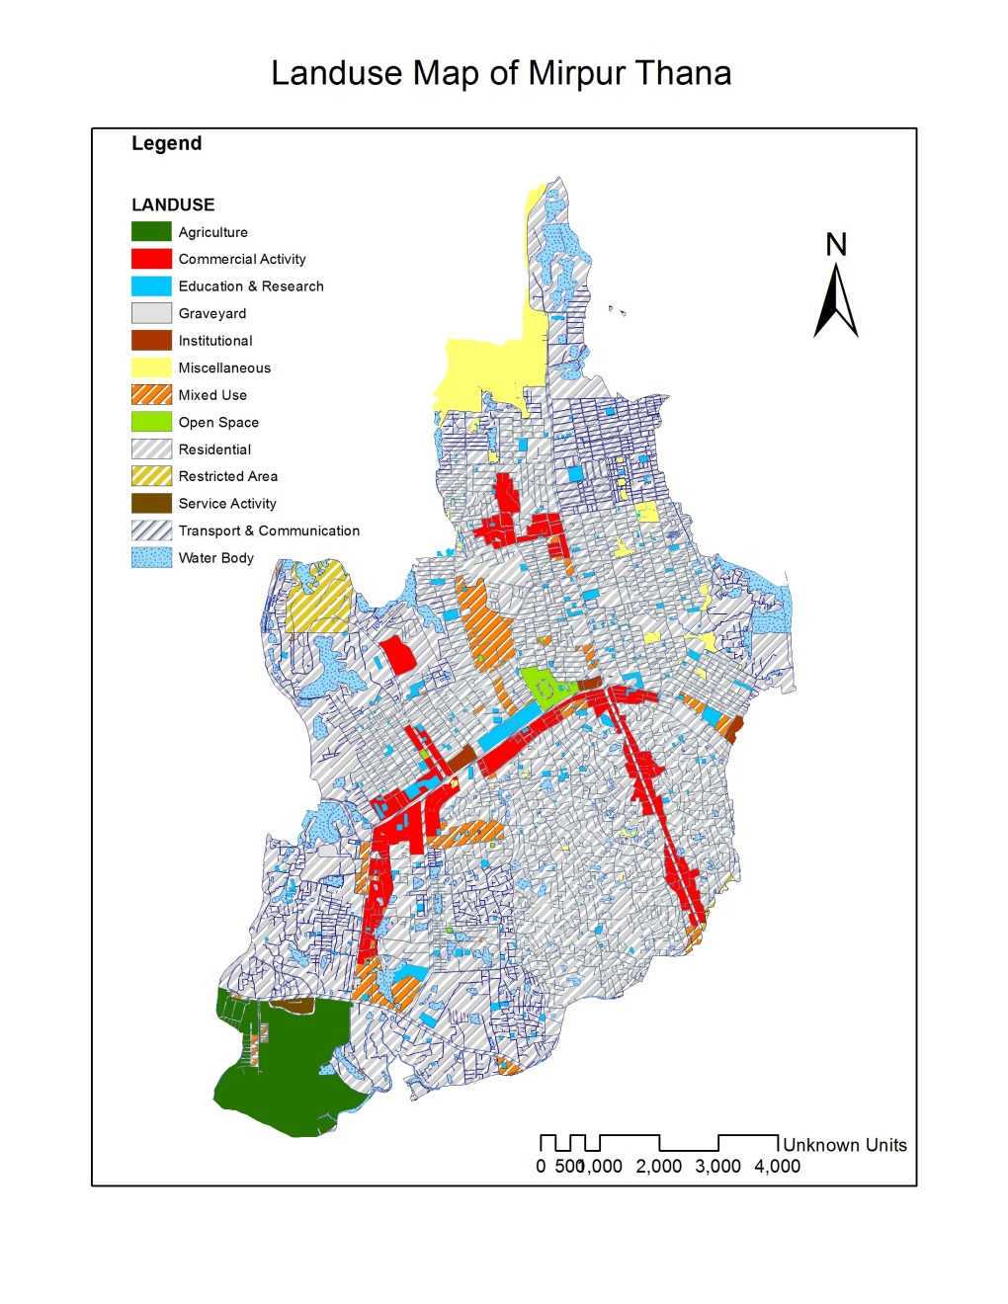

Figure 1: Map of study area

Source: Developed by author with the help of DAP (2014)

Dhaka north area is experiencing the effects of gentrification in an unavoidable manner. This area already has experienced relocation of residents in recent past years. Mirpur can be the greatest example of it. When thana was established in 1962 (Sharif, 2013), the maximum area was allotted for lower class people by government. With the passing time, Mirpur area has broadened and become a suitable living place for middle income people due to lower rate of house rent. For this reason, lower class people are sacrificing their right and being displaced by new middle class. So Mirpur has been selected as study area to study the affordability loss of housing by gentrification.

**4. Definition of Gentrification**

It is the process by which higher income households displace lower income residents of a neighborhood, changing the essential character and flavor of that neighborhood. Gentrification is a complex phenomenon with its exact causes relatively unknown due to the fact that no one theory seems to suit all cities where this process has occurred. However, through many studies, the reasons for gentrification have been shown to be diverse depending on the needs of the new inhabitants.Although there are several definitions of gentrification, the process has a common theme of taking place in an urban context (Atkinson 2000) and being associated with the movement of elite stakeholders into existing working class and lower income city neighborhoods (Teelucksigh 2007). In addition, Benzhaf and McCormick (2007) in their review of gentrification literature have identified three hallmarks that define the term gentrification: (1) rising property values and rental costs; (2) new construction or renovation upgrading the housing stock and converting it from rental to owner-occupied units; and (3) a turnover in the local population, bringing in residents with higher socio-economic status (Banzhaf and McCormick 2007).

**5. Displacement**

Displacement can be defined as a process whereby households have their housing choices constrained by the actions of another social group. There are different forms of displacement and correspondingly different measures of the number of people affected. Marcuse (1986) distinguishes four types: a) Economic/Physical, where residents priced out or subjected to violence are estimated b) Last resident, counting only the last resident c) Chain, counting the residents, over time, which have been displaced from a property or area and d) Exclusionary, where the number of people is estimated who are unable to move into property which has been vacated voluntarily yet subsequently gentrified.

**6. Evaluation of Affordable Housing by Gentrification**

The only official definition comes from Scottish Planning Policy which defines affordable housing as “housing of a reasonable quality that is affordable to people on modest incomes, affordable housing may be in the form of social rented accommodation, mid-market rented accommodation, shared ownership, shared equity, and discounted low cost housing for sale including plots for self-build and low-cost housing without subsidy”. This is a fairly broad definition that can be roughly characterized as housing available to rent or buy at below the level of the market. So it is clear that housing affordability can be decided by house rent. Gentrification process is mainly defined by the rent gap from Smith’s rent gap theory.

**6.1 Smith’s Rent-Gap Theory**

According to Smith’s “rent gap” thesis, gentrification occurs when there is a mismatch or a “rent gap” between potential economic returns from a centrally located building and the actual economic gains from its current use. The investment in rehabilitation, reconstruction, or new construction takes place only when it is profitable, or in other words, if the gains that the structure can generate from its future use is more than the cost of investing in it. Later, Lees et al (2010) argue that although the rent gap thesis seems logical, it is difficult to measure empirically. They further explain that this measurement issue was the main point of contention between Neil Smith and David Ley. Ley made four types of gentrification; which were:-

* Demographic change
* Housing market dynamics
* Urban amenities
* Change in economic base

But after ley, smith developed that hypothesis by thinking the change in household social status which means in simple word ‘the change in purchasing power of money”.

**6.2 Evaluation of Class Structure for House Rent Study**

The changing class structure of capitalist societies has for several decades been a major contributing factor for gentrification, where the debate essentially boils down to the longitudinal *character* of the class structure (how many people fit into certain pre-defined class categories), and to a lesser extent how class struggles and class differences are reconfigured and redefined in the context of wider macroeconomic, social and cultural transformations. For the conduction of gentrification study in Mirpur area, it was very necessary to define the class standard of people on the basis of their income. To identify the proper class segment for gentrification analysis, classification has been on the basis of spending income for house rent. From previous literature reviews, following standard for classification pattern has been established.

Table 1: Percentage of spending for house rent by different class

|  |  |
| --- | --- |
| Class of people | Percentage of spending income for house rent |
| Upper class | Less than 35% of total income |
| Middle class | 35%-45% of total income |
| Lower class | 45% up of total income |

Source: Redeveloped by author with help of literature, 2015

From field survey, it has been concluded that, the maximum citizen of Mirpur area are middle class people on the basis of their spending pattern for house rent. The upper class and lower class people ratio is very close in number. The given figure represents information regarding this. Middle class people can be further classified into higher middle class and lower middle class on the basis of their saving pattern. For gentrification study, the middle class people are classified into new middle class, who are actually consuming the essence of better facilities and being fit with the changed lifestyle.

Source: Field survey, 2015

Figure 2: Classification of surveyed peopl

**6.3 House Rent Increasing Scenario of the Study Area**

***6.3.1 Average per Square Fit House Rent***

Smith then further developed his hypothesis with Lamarch, and then the issues of displacement, forced out shift, strong purchasing power, rent gap and residential mobility pattern was focused. Lamarch gave influence on the existing maximum house rent for present land use, rather than the perfect land use for maximum value. From the dualistic hypothesis of Smith and Lamarch, rent gap analysis for a developing country in Bangladesh has been developed. The purchasing power for house in Mirpur has been identified by four types of rent-gap analysis:

* Average per square fit house rent for the whole study area
* Per square fit house rent for different dwelling unit
* Area wise house rent gap with DNCC fixed standard
* Increasing trend of house rent

By analyzing in these four categories, the purchasing power parity has been concluded for all class of people. From 200 household surveys, the average per square fit house rent has been concluded 11.6 tk. The different dwelling unit house rent can be defined by following table.

Source: Field survey 2015

Figure 3: Average per square fit house rent

Less than 600 square fit dwelling units include tin shed and mess type housing for lower class people who are living there not only for low house rent but also for short distance from workplace. In ward no 4, 5 6, 9, 10, 16, this type of housing are available. Mirpur 14 Baishteki, Baunia beribadh, Albodi Rupnagar tinshed, Golartek, Chotodiabari Jahanabad, Goidartek areas are still now lowest house rent area due to the existence of slum and squatter settlement area.

Dwelling unit of 700-1000 square fit is mainly availed by lower middle class people. Higher middle class and upper class people prefer for taking up the dwelling unit of more than 1000 square fit. Ward no 6, 7, 8, 14 has become middle class residential unit due to the rapid development of apartment housing.

***6.3.2 Area Wise House Rent Gap***

In Bangladesh context, People only think that they could have availed maximum benefit from their property only by commercial use. Though residential development is important for urban area, maximum people make vertical development of housing by thinking about the commercial benefit. For this reason, mixed use has been promoted a lot. So smith’s rent gap theory as the amount that can be capitalized under the lands highest and best use is differed for a developing country like Bangladesh, where housing development is necessity for giving provision of residence, rather than planned development.

Table 2: Rent gap with DNCC standard

|  |  |  |
| --- | --- | --- |
| Area | House rent in per sq ft | House rent standard from DNCC |
| Ward 2 | 12.5 | 6 |
| Ward 3 | 12.5 | 8 |
| Ward 4 | 7.5 | 5 |
| Ward 5 | 12.2 | 5 |
| Ward 6 | 8.5 | 5 |
| Ward 7 | 8.5 | 7 |
| Ward 8 | 11.5 | 6 |
| Ward 9 | 12.5 | 6 |
| Ward 11 | 10.5 | 7 |
| Ward 12 | 13.5 | 7 |
| Ward 13 | 11.5 | 8 |
| Ward 14 | 12.5 | 8 |
| Ward 15 | 11.5 | 5 |
| Ward 16 | 13 | 7 |

Source: Field survey, July 2015 and Office Interview of DNCC, 2015

For this reason, rent gap has been measured in a different way, the gap between the fixed standard of DNCC and the existing rent in per square fit. Present land use and its potential ground rent in our country is decided by the land owner for different reasons rather than given standard of authority. For higher construction and development cost, owners have to fix rent for maximum potential ground rent, So that they can avail at least better rent under land’s better use in the case of capitalized best use. The given table is showing the existing house rent of different wards in per square fit and the DNCC fixed standard for those areas. Rent gap among the fixed and existing use are clear by this table.

***6.3.3 Increasing Trend of House Rent***

In a middle income country like Bangladesh, housing provision is like a challenge for urban areas with lack of planning. Every year capital Dhaka has to bear intolerable pressure for new housing provision, due to higher rate of migration and attraction of better facilities. Mirpur thana has become a gentrified area due to its housing pattern. In one side, housing rent of this area is quite affordable for middle income people than other residential areas of Dhaka city, because the housing was actually provided for lower class. On the other hand, due to the attraction of facilities and commercial development, house rents of this area have increased with the increased proportion of different facilities. The following bar diagram represents the curve pattern of house rent increase of last decade.

Source: Field survey, 2015

Figure 4: Trend analysis of house rent in Mirpur

For increasing trend of rent analysis, we have taken house rent data of Mirpur of last decade, with a gap of five year, change in house rent trend in quite clear. Though the government becomes changed in our country with five year gap, budget plays an influential impact for fixing new rent standards by government.

**6.4 Reasons for House Rent Increasing**

There are many reasons for house rent increase. The overall socio-economic, political and physical condition of a country is responsible for this social crisis.

Location is an important factor to influence the house rent in a particular area. In absence of any other variables a household would be expecting to choose a location to maximize personal benefit. One of the important factors to determine the level of rent variation of a housing unit is accessibility. It is defined in terms of physical as well as social access to various locations. Of these access to place of work and distance of workplace from house is usually of supreme importance (Islam, 1973).

Other kinds of accessibility, which are often considered desirable, include access to shopping centers, to katcha bazaar, to educational institutions (such as school, college, kindergarten, etc), to recreational areas, to medical center/hospital/clinic, to religious institutions (such as mosque, church, temple, etc.) and to other residential areas, which people may visit as part of the social activity pattern. Physical character of the area in which a house is located can directly affect its rent. In planned areas rent is normally higher than in old and unplanned areas. Social environment of the area also affect the variation of house rent.

But in the case of gentrification, reasons for house rent increase are little bit different. Though the reasons are not too much familiar, but their impacts are huge in the progress of house rent. The following figure is representing the reasons behind house rent increase in Mirpur.

Source: Field survey 2015

Figure 5: Causes of house rent increase

***6.4.1 As Wish of Owners***

Excess cost for construction materials, pipe service lines for utilities and maintenance creates loan for house owner while building apartments or house. So they try to recover these costs by fixing more house rent. From field survey, it has been concluded that, 10% people think the main reason of house rent increase is by the wish of house owners.

***6.4.2 Price Hike***

Price hike is the main explained reason by house owners in Dhaka city. Living cost is raising high day by day, to exist in Dhaka city by maintaining food and accessories cost, people have to struggle. House owners are not except of them. Many of them have no other income source without house rent, so they increase house rent for maintain their own living cost in accordance with maintenance cost. 41% people described price hike is the main reason of house rent increase.

***6.4.3 Increase in Utility Bill***

Another most important factor is utility bill, which play significant role in the variation of house rent in the study area. In this study, the terms of utility service includes availability of water supply (all time supply of water), gas connection and electricity supply. For their connection and maintenance cost, generator, water tank establishment etc. increases the utility bill which forces them to increase house rent. 24% people remarked that, increase in service facility bill is the main reason of house rent increase.

***6.4.4 Increase Income of Renters***

Both for government and private job employee, increase in salary becomes burden when owners also increase the house rent, in accordance with that. It’s a common thought in our country that if one is getting more salary, he has the ability to pay more for services and residence. So house rent increases here for post up gradation. 22% people have faced the situation when house rent has increased for their post-up gradation.

From field survey, it has also been concluded that some owners have increased house rent for without mentioning any valid reason. In this segment, owners have blamed tax burden on them for increasing rent.

**7. Outcomes of Losing Housing Affordability through Gentrification**

The consumption theory of gentrification contends that the demographics and consumption patterns of this "new middle class" that is responsible for gentrification and the suffering of gentrifier class. But the consumption pattern doesn’t remain same for middle and lower class people. Due to rent gap caused by gentrification, people have to loss their housing affordability not only just for rent but also for the impacts of increasing displacement situation. Atkinson, 2000 suggests a range of outcomes from gentrification-related displacement including:

* A loss of housing options for growing sections of the community and a loss of the demographic and social mix that comes with housing tenure diversity and cost variability;
* Fewer housing options for the more vulnerable members of the community;
* Effects on the psychological health and support networks of displaces resulting from making involuntary housing choices in pressured housing markets;
* Spatial mismatches as work opportunities are located further away from residential options and potential brakes on economic growth as businesses seeking low-waged and low-skilled workers find it more difficult to locate in high housing cost enclaves.

These outcomes create further problem for people for which, both lower and middle class people have to suffer for losing affordable housing. Lower class people suffer for increasing house rent which have discussed before. Middle class people suffer mainly for poor services. The major outcomes for losing affordability of housing through gentrification are discussed blow.

**7.1 Promotion of Slum and Squatter Settlements**

Most important impact of gentrification is promotion of slum and squatter settlement. In our study area, gentrification process has been promoted slum and squatter settlements than before. Rapid displacement forced people to live in slum or squatter settlements which have created their life measurable. If we take a look in the following map, it will be clear that, the sudden emergence of squatter settlements in the study area has made some portions of the study area as vulnerable. From field study, we have classified the problematic areas as slum, vulnerable and opportunity based areas. Apart from Rehabilitation allotted areas, some new areas have also been included here.

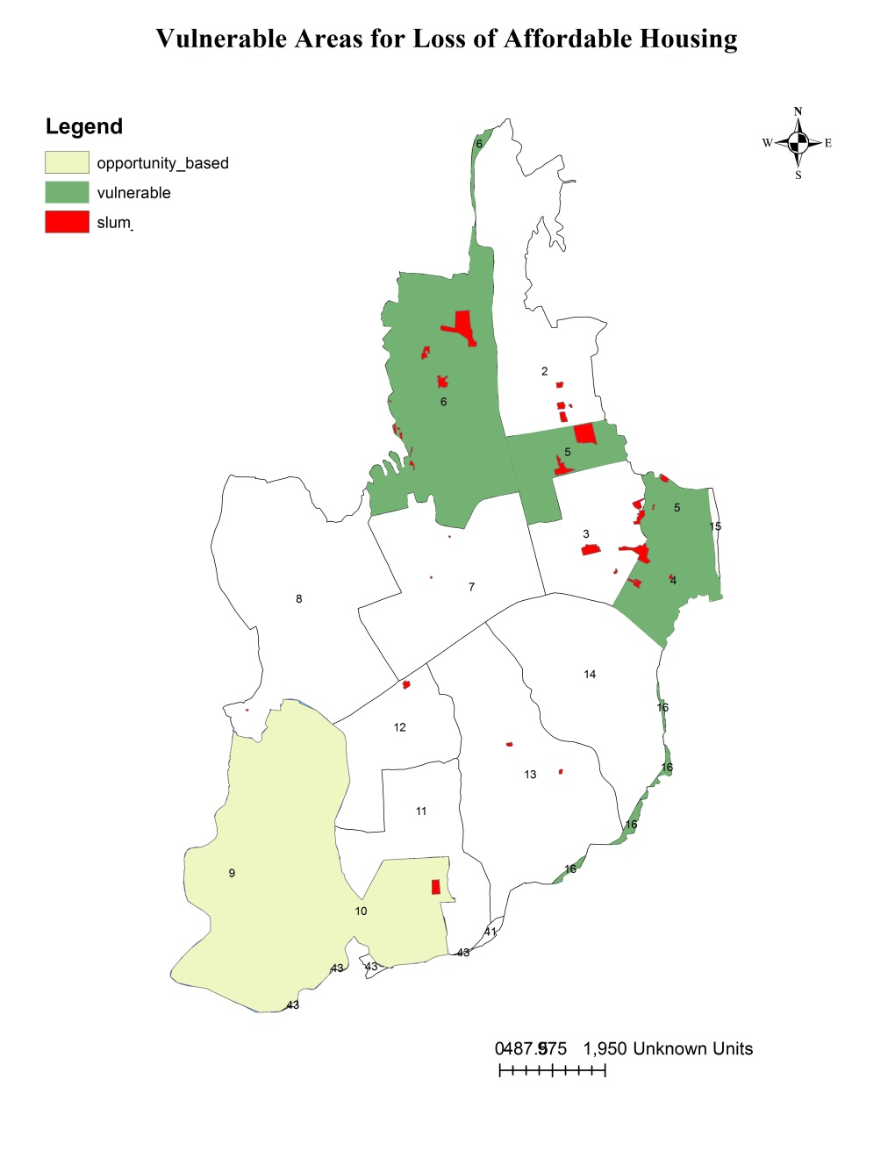

Source: Developed by author with the help of DAP (2014)

Figure 6: Vulnerable areas for loss of affordable housing in the study area

**7.2 Deterioration of Public Health**

Public health is being greatly affected when people are being displaced. Both the physical and mental health are being disturbed when people have to live lower quality places or have to move out forcibly. Sometimes it really needs long time to adjust in a new area after displacement and the children suffer more especially.

**7.3 Sacrificing Utility Service Facilities**

Both the middle and lower class people have to suffer for utility service facilities. Middle class people sacrifice this in spite of being suffering due to avail low hose rent. On the other hand, lower class people suffer for having poor utilities due to become unable for paying rent for better housing. Poor water supply, lack of waste management facilities, weak drainage system affects public health measurably.

**7.4 Enhancement of Violence and Crime rates**

Promotion of slum and squatter settlements enhances violence and crime rates. When people are being deprived of basic and regular needs, the have to adopt various unfair means which promote crime. Sometimes safety becomes a major issue for a residential area where security for residents is hampered due to crimes. Displacement causes this negative experience in residential areas for both middle and lower class people.

**7.5 Social and Environmental Justice**

The purchasing power disparity for paying rent of housing creates divider between different class people. The comparatively rich class own better options for living where comparatively poor class cannot afford the better one. Social imbalance is promoted by that. Environmental condition is being disturbed when poor people misuses the natural resources for meeting their basic needs. High density in lower class area and its impact degrades the sustainable environment.

**8. Proposal from planning perspective to enhance Housing Affordability**

**8.1 Assessment**

An assessment will involve community mapping efforts that identify:

* renter-to-homeowner rates
* vacancy and abandonment rates
* affordability indexes (rent or mortgage as percentage of household income)
* spatial analyses of race and poverty.

**8.2 Action on Four Fronts to Preserve and Expand the Supply of Affordable Housing**

***8.2.1 Stabilize existing renters***

This include

* assessing displacement rates,
* creating emergency funds for rental assistance,
* removing discriminatory barriers that renters face or creating rent stabilization policies such as eviction controls and rent increase schedules.

***8.2.2 Control Land for Community Development***

This will include:

* promoting inclusionary zoning ordinances,
* mixed-use and transit-oriented development
* density provisions

***8.2.3 Build Income and Assets Creation***

* Income and asset creation are critical to ensuring resident well-being as the neighborhood economy improves.
* Community land trusts for low income house owners and for ensuring the affordability of renters can be effective as an asset creation method.

***8.2.4 Develop Financing Strategies***

* Proactive financing strategies can provide neighborhood-specific ways to fund the other three categories of action. They include
* Investments from regional business associations;
* Housing trust funds exactions and fees on commercial developments;
* Tax increment financing and eminent domain;
* Bank investments under the Community Reinvestment Act;
* Community Credit Unions and tax abatements, credits and deferments.

**8.3 Guidelines for responsible authorities towards controlling the loss of affordable housing through gentrification**

Table 3: Guidelines for authorities

|  |  |
| --- | --- |
| **Responsible authorities** | **Responsibilities to control the gentrification process** |
| Rajuk | More housing schemes should be planned |
| Dhaka North City Corporation | Tax collection system should be systematic |
| Zonal Offices | House rent standard should be authorized properly |
| National Housing Authority | Proper estimations of slum and squatter settlements |
| House Building Research Institute | New techniques for the provision of affordable housing for all classed people |
| Planning Commission | Provision of rules and guidelines to control housing problems |

Source- Constructed by author

**8.4 Strategies to avoid the affordability changes through Gentrification**

***8.4.1 Anticipating housing demand and market change***

* Planners can provide demographic projections of household growth, which predict future needs for housing.
* National Housing Authority should make assessment to understand present housing supply and to predict future housing demand.
* Public sector actors must anticipate the speed and intensity with which the private market actors can act quickly to acquire and develop, to buy and sell properties, and to respond to new demand.

***8.4.2 Ensure proper monitoring and implementation of planning rules and regulations***

Planners and other decision-makers need to consider-

* Goals for providing housing of different types;
* Prices;
* Different locations for new housing in response to projected demand and likely unmet needs.

***8.4.3 Regulate and incentivize to coverage limited housing resource***

The kinds of planning and policy tools that are available and most effective should be practiced and more policies for fighting with housing evaluation should be taken by Planning Commission.

**8.5 Core Tools in Action**

Within each of these four categories just described, there are dozens of tools. Here is a list of some of the most important tools, and ideas about how they can connect to each other and to other strategies in order to redirect the development trends that bring out gentrification and displacement impacts and undermine equitable development goals for saving affordable housing options:

* **Community Land Trusts (CLTs)** take real estate off the speculative market and ensure long-term affordability for renters, low-income homeowners, community arts and nonprofit institutions and community-centered businesses.
* **Limited-Equity Housing Cooperatives** are another affordability mechanism; providing a method for renters to acquire their buildings and share in permanently affordable and democratically-controlled home ownership opportunities.
* **Housing Trust Funds**, created by legislation that dedicates ongoing revenue streams to affordable housing, are one of the most promising financing strategies for combating gentrification, particularly if they are used to provide housing that includes long-term affordability restrictions.
* **Inclusionary Zoning and Below Market Rate (BMR) Ordinances** provide an ongoing framework for ensuring mixed-income communities. With significant new development underway, this provision will provide homeownership opportunities for many residents who would otherwise be forced to leave their community. These ordinances combine particularly well with the three core tools listed above.

**9. Results**

**10. Conclusion**