**SLUM DWELLERS UNDERSTANDINGS of THEIR RIGHTS AND ACCESSIBILITY TO PUBLIC SERVICES: A CASE STUDY ON KHULNA CITY**

***Sumaya Sydunnaher***

Urban and Rural Planning Discipline, Khulna University, Khuln-9208, Bangladesh

***Dr. Eng. Kazi Saiful Islam***

Professor, Urban and Rural Planning Discipline, Khulna University, Khuln-9208, Bangladesh

**Abstract**

This paper reveals the slum dwellers understandings of their rights and accessibility to public services. . Nearly one third of total urban population of the country live in slums and squatters. They contribute to the country’s development in different way, but their rights are always overlooked due to their lack of awareness. As a result these Slum dwellers are deprived from many services facilities then the other citizens of the cities and lead inhuman life in this cities. . In this paper quantitative method is used and quantitative data’s are collected from two slums by questionnaire survey. Thirty respondent were selected from each slum. The major findings of this study is none the respondent are fully aware of their rights. And cannot get enough access to various public services due to social discrimination, poverty, powerlessness and lack of awareness and information. So it is urgent to make them aware about their rights so that they can raise their voice and get access to public services.

**Key Words:** Slum dwellers, Rights, Accessibility, and Public services

**1. Introduction**

This paper tends to extract the level of understanding of the slum dwellers about their rights and accessibility to public services in two slums (*Khorabosti* and *Methorpotty*) in KCC. Due to rapid urbanization, rural-urban migration, natural increases in population within urban areas the vast, majority of the urban population are living in slum and squatter settlements throughout the cities of Bangladesh. Nearly one third of total urban population of the country live in slums and squatters (Shamsad, 2016). Basically this slums and squatters are the home of poorest and most vulnerable people of the cities. Most of these people are economic and climatic migrants from rural areas (Hossain, 2004). They contribute to the country’s development in different way, but their rights are always overlooked.

Slum dwellers of the city are not considered as legal occupants even having voting rights. Thus, slum areas do not fall under the basic service delivery systems of the City Corporation. As a result these urban dwellers are deprived from many services facilities then the other citizens of the cities and lead inhuman life in this cities. They cannot raise their voice due to lack of education and awareness about their rights. More than 90% people do not access to law and order and other public services like education, health services etc. which increases their vulnerability. To addressing the problems of the slum dwellers, a number of organizations such as UNDP, UNICEF, NGOs, and the Government have recognized the need to serve the basic needs of the urban poor throughout Bangladesh. But their intervention is very insufficient in compared to their needs (Roy, 2014). So, it is urgent to make them conscious about their rights and increases their accessibility to public services.

**2. Theoretical Framework**

This study explored the following key words like slum dwellers, rights, accessibility, and public services. In general the people who lives in slum is called slum dwellers, and According to (UN-habitat, 2003) slum refers to highly congested urban areas marked by deteriorated, unsanitary buildings, poverty, and social disorganization. Hossain (2004) classified slum in two ways on the basis of ownership: 1) public slum 2) private slum (Hossain, 2004). Rights dominate modern understandings of what actions are permissible. On the other hand, accessibility refers to the quality of being available when needed. This study viewed accessibility as the ‘ability to Access’ and benefit from some structure or entity. This study measures the rights and accessibility including basic needs and services, information services, and participation in the local institutions and activities. Besides a general definition of public (basic or essential) services is ‘Publicservices are basic services provided for the general public at large by key government departments and non-departmental public bodies’ (Hossain, 2004).

In Bangladesh, especially Khulna city, most of the research on slum focus on poverty, health, living environment, sanitation and water supply etc. and rarely give focus on slum dwellers rights and accessibility to public services. For example (Shamsad, 2016) discusses the impact of the basic services on physical and social development of the slum areas by using comparative scenarios between before and after service provision of Khulna’s slum areas and found that slums environment has been improved substantially due to different projects, but provision of services is notably low than demand. Roy (2014) examined sustainability options of sanitation projects in the slums is Khulna city (Hossain, 2004). Hossain (2004) found that the urban poor in Dhaka city are advantageous to get access to public services (Hossain, 2004).

From the above discussion, it is clear that there is rarely a discussion about the rights and accessibility of slum dwellers to public services, and there is a knowledge gap. This study attempts to discuss the slum dwellers awareness about their rights and accessibility to public services, thus contribute to the available information on slum dwellers.

**3. Objectives**

The main objective of this slum is to extract the level of understandings of the slum dwellers about their rights and accessibility to public services in two slums in KCC. To achieve this objective, following research questions are being answered:

1. What is the level of understandings about their rights including women’s experience of the violation of their rights?
2. How is the accessibility of the slum dwellers in Public services?

**4. Methodology**

**4.1 Study Area**

This study is carried out in two slums (*KhoraBosti*and *Methorpotti* ) in Khulna city Corporation (Fig8, page-10)*. Khorabosti* is nearer to the main bus station & health services (Khulna Medical College hospital). This is a private slum and people live here by paying house rent. People of this slum are not aware of their rights as they are not living here permanently. It is found that responsible authority does not eager to do anything here (T. T. Tanni, 2014). Besides, the *Methorpotti* is situated on the railway land near *Joragate.* It is a public slum. So, always there is a threat of eviction. Slum dwellers of this slum are socially excluded due to their low cast system. As a result most of the cases they faces severe problem to get access in public services.

**4.2 Research and Data Collection Method**

This Study applied quantitative approach. In this research, structured questionnaire method were used for quantitative data collection through random sampling. Two slums (*Methorpotti* and *Khorabosti*) in Khulna city were taken as samples. Thirty households were taken as respondents households from each slum. The respondents are selected randomly as ease to access. Among 60 respondents the number of male respondents are 31 and female respondents are 29.

**5. Analysis**

**5.1 Slum dwellers understandings of their rights**

This findings reveals that none of the respondents understand about their rights partially or fully. The highest no of respondents who are little aware about their rights are found in public slum *(Methorpotti*) and highest number of respondents who are not aware abouttheir rights are found in private slum (Khora slum) Fig-1).



10

20

14

16

0

5

10

15

20

25

Don’t Know

Little

Understanding

Partially

Understandings

Fully

Understanding

**Peoples Understandings of their rights**



Public Slum



Private Slum

Figure

1

:

Slum Dwellers Understanding Of their Rights (Sample size

60)

**5.2 Women’s awareness about the violation of their rights**

This study is conducted to explore physical and psychological violence within households to women. This type of violence indicates the violation of

women’s rights. In the study area it is found that physical and psychological violence is comparatively higher in private slum (*Khorabosti*) (fig 2). Dowry, not allowing free movement, extra marital affairs, divorce or threat to divorce, and family problem are the main factors of psychological violence (fig 2).

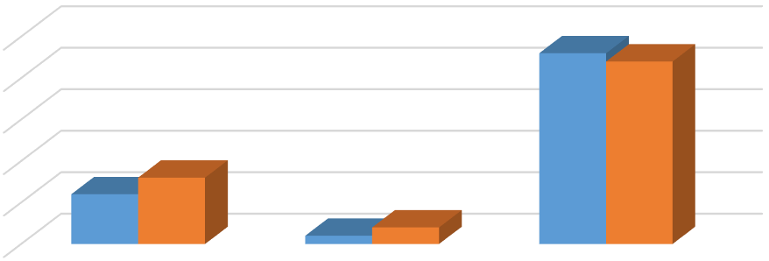

0

5

10

15

20

25

Psychological Violence

Physical Violence

No

**Nature of violence within HH against women**

Public

Private

Figure 2:

Nature of violence within HH against women (Sample size 60)

It is also found that 2/3of the people are not aware to report. Some people report to local leader. Very few people report it to police station.

**5.3 Accessibility to Basic public services**

This analysis reveals that the accessibility to city corporation/word council is higher than others (fig 3). Accessibility to police stations is very low due to dependency on local leader and low performance of police station. The accessibility to school is also relatively low than other services and social discrimination, poverty, engagement in reproductive work is the main factors of this less accessibility to school.

Figure 3: Access to government Services (sample size 60)

38

%

11

%

72

%

51

%

**Access to Government services**

School

Police Station

City corporation/Word council

Govt Hospital

**5.4 Accessibility to KCC/ Word Council services**

The accessibility to death and Birth certificate is highest in both public and private slum (fig 4). In private slum there is no accessibility in tax collection, information services. In private slum there is also no accessibility to KCC School and Conservancy Division and the number of respondent who have no accessibility to any *services* is relatively higher in private slum.

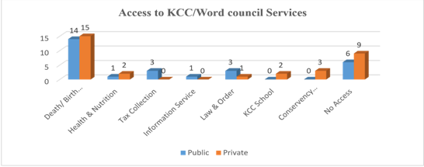

**Figure 4: Access to KCC/Word council services (sample size 60)**

**5.5 Accessibility and Mobility analysis**

In public slum (*Methorpotti),* accessibility to KCC and school is low in comparison to mobility (fig 5). The accessibility and mobility to police station and government hospital is notably low in public slum due to lack of attentiveness and long distance. In private slum (*Khorabosti),* accessibility to school is higher than mobility. In terms of government hospital and KCC mobility is higher than accessibility**.**

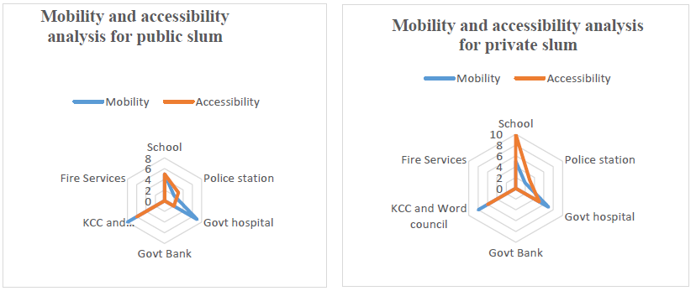

Figure 5: Accessibility and Mobility analysis for public and private slum (Sample Size 60)

**5.6 Performance of KCC**

This findings reveals that only 5% people are fully satisfied followed by 43% are moderately satisfied, and 35% are dissatisfied with the performance of KCC (fig 6). It is found that the performance of KCC is moderately well.

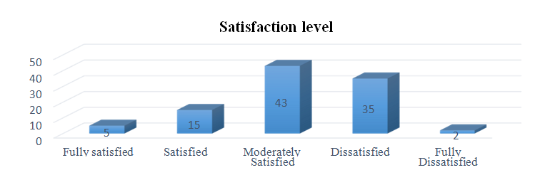

Figure 6: Performance of the Khulna City Corporation (sample size 60)

**6. Findings and Conclusion**

This study attempts to extract the level of understandings of the slum dwellers about their rights and accessibility to public services. The analysis of this study reveals the following findings:

1. Most of the slum dwellers are not aware about their rights due to lack of education. This tendency is higher in public slum than private slum.

2. The tendency of violation of rights against women is higher in private slum. Most of the family involve in psychological violence due to dowry, threat to divorce, family problem. It indicates that the dwellers in private slum suffer from depression. Very few people report this to the local leader. Majority of the sufferers keep silent. From this it is found that they do not have access to law and order even they don’t know how to proceed to get access in law and order.

3. The accessibility to school is relatively low than other services. In private slum dwellers do not send their children to school due to poverty, engagement in reproductive and productive work because they have to pay house rent which is the extra burden to the private slum dwellers than the public slum dwellers. Besides, in public slum, the slum dwellers face social discrimination in the nearest school due to their low cast system. So, they have to send their children in Railway School which is 2 km away from the slum. As a result the school attendance decreases.

4. Accessibility to police station and law and order is low in both slums. They slum dwellers do not get expected services which makes them dependency on local leader. As a result they become powerless. They cannot raise their voice if the local leader do anything wrong.

5. The public slum dwellers do not have the accessibility to conservancy division in KCC. They do not get any benefit from this division like waste collection, drainage, etc. Even most of slum dwellers do not know that it is their legal rights to get these services.

6. The participation in local govt. of the slum dwellers in both public and private slum is notably low. It indicates that there is a little scope to express their demand in front of local government.

This study is conducted in two slums in Khulna city. The findings of this study reveals some backwardness like lack of awareness about their rights, poverty, social discrimination, dependency on local leader hinders their accessibility to various public services which makes them more vulnerable. So, it is important to make slum dwellers aware about their rights.

**REFERENCE**

1. HOSSAIN, R. A. M. T. A. J. 2004. BARRIERS TO ACCESS TO PUBLIC SERVICES FOR THE URBAN ENQUIRY INTO DHAKA SLUMS. Journal of the Institute of Bangladesh Studies, XXVII.
2. ROY, T. K. 2014. Sustainability Options of Sanitation Projects in the Slums of Khulna City.
3. SHAMSAD, B. S. A. S. 2016. Improving the Living Environment of Khulna City Slum Areas, Bangladesh: Impact of Basic Services. GBER, Vol. 3 No. 3**,** pp 49 - 60.
4. T. T. TANNI, M. J. H., A.K. AZAD AND B. BAKALI 2014. State of the Environment in Slum Area: A Case Study on Khora Slum, Khulna. J. Environ. Sci. & Natural Resources**,** 295 - 304.