**Flood Extent Mapping Using SAR Satellite Image of Bangladesh:**

**A case study in Rajshahi, Naogaon and Natore**

**M. S. Reza**[1]**, L. Ferdous2**, [**T. Chakraborty**](https://mobile.facebook.com/Torit99?refid=12)3

**ABSTRACT**:

Bangladesh is a flood prone area among Asia for the geological location. Due to this natural disaster, infrastructure damages and human life losses occur every year in our country. Efficient monitoring and prediction of flood in our county is completely impossible without using satellite data from space .Flood mapping is a process which use for damage assessment and risk management and helping rescuers during flood. The objective of this study is to define the extent of flood. The study area is the north western part (Rajshahi, Naogaon and Natore) of Bangladesh. The whole analysis is based on Earth Observation(EO) Data SAR (synthetic aperture radar) satellite image from sentinel-1 from space, has free access from ESA .SNAP software is used for SAR imagery processing using threshold method to derive the flood extent and ArcGIS ,Google earth are used to visualize the result of image processing. The results help operating estimation and detection of flooded area and determine the extent of present year what caused the water from the past year in the damaged area during flood.

**Keyword:** Flood Extent, SAR Image, SNAP Software, Flood Mapping

**Introduction:**

A flood is described as an overflow or increase of the expanse of water which submerges urban or rural land. The sense of "flowing water" is basically the inflow of the tide. It result from the rising volume of water to the water flows its usual boundaries of village, city or other inhabited area. Floods may occur in rivers where strength of the river is so high it flows out of the river channel and causes damage to homes and businesses along such rivers. ("Flood concepts", 2017) In Bangladesh, there is occurring repeated periodic flooding. A report conducted by World Bank group which listed Bangladesh, of 165 million populated country, considered the world's "potential impact hotspots" threatened by "extreme river floods" due to global rise in temperatures. Much of the country is built on low-lying and flood-prone areas, which made it particularly vulnerable to seasonal monsoon rains. In 2007, Bangladesh was seriously damaged by deadly monsoon flooding which led to over 1,000 deaths and in 2017 history is repeating. (Steve George, 2017) Flood Maps can be described as a tool in which flood waters are anticipated to extend for a range of different sized flood events. (“Flood check”, 2017)

Relevant study on the flood extend mapping have done to identify the intensity of the flood locations. The study areas are Rajshahi, Naogaon and Natore of Bangladesh. Earth Observation (EO) data collected from space is being used for effective monitoring and prediction of floods and risk management for large river. The flood extent information is used for vulnerability and risk assessment which is beneficial to rescuers during flooding. The main problem of the determination of extends of flood area and monitoring is that a compact network of observations cannot provide accurate information. Mainly the data required for the flood extend mapping is SAR (synthetic aperture radar) images, for SAR image analysis SNAP tool is used, DEM for ortho-rectification (SRTM dem automatically downloaded in SNAP), archieved optical images, land cover/ land use maps with vector data. ("In Detail: Recommended Practice Flood Mapping", 2017) The time selection of the conducted image is to be considered due to the weather condition and image processing should be operational by skilled personals for detection of the flooded area ("Recommended Practice: Flood Mapping", 2017). The methods and procedures in the relevant studies were followed to some extent to achieve the accurate flood extend map of the research area.

Basically, the objective of the research practice is to determine the extent of flooded areas of considered research area. The research explores the flood extend map which includes damage assessment of flooded objects, operational mapping and response, recovery and understanding the severity of flood from the previous year. The application of SAR satellite image leads to a fast image processing system and provides reliable flood extension area. The study a helped to risk assessment for vulnerable population, economic activity and potential location at the risk of flooding.

**Materials and Methodology:**

The materials for the research are Sentnel-1 images, SNAP 2.0 (S1 Toolbox), ArcGIS 10.2.2 and Google Earth. A simple threshold method is applied for deriving flood extent from SAR imagery. The research conducts the following steps in SNAP software: Data preparation, pre-processing (Calibration, Speckle filtering), binarization by band math’s, Post-processing (Geometric correction) and then ArcGIS software: image processing for the visualization in Google Earth. Basically data preparation includes all the major data formats which are used for SAR image processing. For data preparation, sentinel-1 images of 27th August,2017 and 28th August,2016 are collected from ESA website, metadata for polarization of intensify bands are used. The images were georeferenced, filtered with the adaptive Gamma filter and masked. Pre-processing includes calibration and spectacle filtering. Binarization is used to separate water from non- water region and it also analysis the filtered backscatter co-efficient where magnitude depends on the data. In next step post processing is done by the geometric correction (by re-projecting geographic projection using Digital Elevation model-DEM which downloaded automatically and SAR images). Finally, ArcGIS 10.2.2 are used to make flood extent map of the studied area (Rajshahi, Naogaon and Natore) and to visualization of the water band in google earth is resulted to the flood extend map which classifies the water regions.

**Results and Discussion:**

**Flood extent to the floodplain:**

Two different sentinel-1 images are used for understanding the flood extent in Rajshahi, Naogaon and Natore districts. Table 01 and Figure 01 represent a comparison of the extent of mapping of Rajshahi, Naogaon and Natore from August 2016 to August 2017 which was determined by sentinel image processing. The analysis has made a sense to understand the extent of the inundation of water of the present-past year. The extent of flooding evaluated is only illustrating the increase in flood extent from the previous year and not the entire extent.

**Table 1.** Total flooding area of the study area in 2016 and 2017

|  |  |  |  |  |  |  |
| --- | --- | --- | --- | --- | --- | --- |
| Study Area | Rajshahi | | Naogaon | | Natore | |
| Flood year | 2016 | 2017 | 2016 | 2017 | 2016 | 2017 |
| Total Flooding area (in km2 ) | 227.59 | 203.12 | 246.164 | 514.67 | 179.032 | 176.032 |

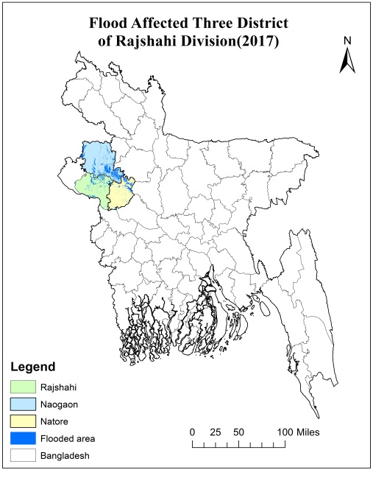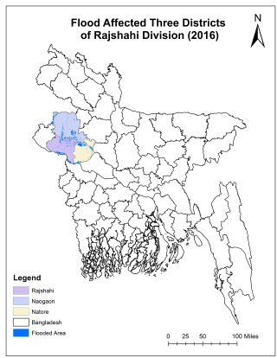

**Figure 01.** Flood affected three districts of Rajshahi Division of 2017 and 2016

(Source: Prepared by Researchers)

|  |  |
| --- | --- |
|  | Flood extent of Rajshahi district is less in 2017 than 2016 . From table 01. In 2016 , the flooded area was 227.59 sq. km and in 2017 , the area is 203.12 sq. km since August. The total area of Rajshahi district is 2382.22 sq. km. The flooded area was 9.55% and 8.52% respectively in 2016 and 2017 of total area of Rajshahi district. The flood extend area has decreased 1.03%. |
| **Figure 2.** Comparison of flood extent mapping of Rajshahi in 2017 and 2016 respectively | |
|  | Flood extent of Naogaon has increased in amount this year. From table 01. In 2016, the flooded area was 246.164 sq. km. and in 2017, the area is 514.67 since August. The total area of Naogaon is 3449.22 sq. km. The flooded area was 7.13% and 14.92% respectively in 2016 and 2017 of total area of Naogaon district. The flood extend area has increased 7.79%. |
| **Figure 03.** Comparison of flood extent mapping of Naogaon (2017 and 2016) | |
|  | Flood extent of Natore is less in amount in 2017. From table 01. In 2016, the flooded area was 179.032 sq. km and in 2017, the area is 176.032 sq. km since August. The total area of Natore is 1914.195 sq. km. The flooded area was 9.35% and 9.19% respectively in 2016 and 2017 of total area of Natore district. The flood extend area has decreased 0.16%. |
| **Figure 04.** Comparison of flood extent mapping of Natore (year 2017 and 2016) | |

(Source: Prepared by researchers, 2017)

**Time to flood:**

The extent of flooding between August 2016 and August 2017 was determined from the Sentinal-1 images. Fig 2, 3 and 4 represents a comparison of flood extent of present year and past year. In Fig 2, 3 and 4, the flooded areas has increased from the previous year which covers a huge extent of lower areas of three districts from which the flood extent covers a huge of area of Naogaon district in 2017. But, the conditions have almost remained unchanged in Rajshahi and Natore districts in past and present condition. The time to maximum flood extent is very rapid in the Naogaon Floodplain, depending on the season. However, the extension of flood are causing damages in the affected area during this year. To find out the affected area are visualized in Google earth.

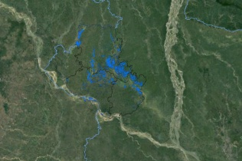 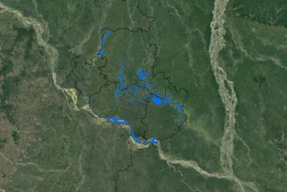

**Figure 5.** Visualization in google earth respectively year of 2017 and 2016

(Source: Prepared by researchers, 2017)

From the Google earth images, it helps to find out easily the flooded area among three districts. Fig 5, shows the flooded area respectively years of 2017 and 2016. It visualizes the part of earth causing under damages during this year till August and helps to damage assessment and risk management.

**Conclusion**

Flooding is considered as a disaster worldwide as many people were evacuated by the flood, experienced property damage or loss, or was threatened by the loss of food security (IRIN 2009). Flood extent mapping is used all over the world to mitigate the property or life loss by flooding. From the analysis, it is already found that it is very effectual for damage assessment and risk management. Besides, this types of map help rescuers to find out the flooded area by visualizing in google earth. As every year flood occurs in our country, the practice of flood mapping can save many lives and properties from damages.

# References

Check, F. (2017). Retrieved 1st september, 2017, from https://[www.moretonbay.qld.gov.au/uploadedFiles/moretonbay/living/floodplains/interpreting-suburb-maps.pdf](http://www.moretonbay.qld.gov.au/uploadedFiles/moretonbay/living/floodplains/interpreting-suburb-maps.pdf)

Concepts. (2017). Flood. Retrieved 1st september, 2017, from https://[www.concepts.org/index.php?title=Flooded](http://www.concepts.org/index.php?title=Flooded)

IRIN. (2009). "Food insecurity looms as floods swallow crops", Retrieved 1st september, 2017, from <http://www.irinnews.org/news/2009/03/24>

Pustina, A. (2014a). In Detail: Recommended Practice Flood Mapping. Retrieved 1st August, 2017, from <http://www.un-spider.org/advisory-support/recommended-practices/recommended-practice-flood-mapping/in-detail>

Pustina, A. (2014b). Recommended Practice: Flood Mapping. Retrieved 1st August, 2017, from <http://www.un-spider.org/advisory-support/recommended-practices/recommended-practice-flood-mapping>

Pustina, A. (2014c). Step by Step: Recommended Practice Flood Mapping. Retrieved 1st August, 2017, from <http://www.un-spider.org/advisory-support/recommended-practices/recommended-practice-flood-mapping/step-by-step>

George, S. (2017) "*A third of Bangladesh under water as flood devastation widens*", Retrieved 1st september, 2017, from <http://edition.cnn.com/2017/09/01/asia/bangladesh-south-asia-floods/index.html>

1. *Undergraduate student, Dept. of Urban and Regional Planning, Rajshahi University of Engineering & Technology, Rajshai-6204, Bangladesh.*

   2 *Undergraduate student, Dept. of Urban and Regional Planning, Rajshahi University of Engineering & Technology, Rajshai-6204, Bangladesh.*

   3 *Undergraduate student, Dept. of Urban and Rural Planning, Khulna University, Khulna-9208, Bangladesh.*